

MU Student AI Scale Canvas Pages
This page provides descriptions and pictures of each option, followed by instructions on how to find those pages and import them from Canvas Commons into your course.

Canvas Pages Options
- Standalone MU Student AI Use Scale: This page is a Canvas version of the Student AI Use Scale. 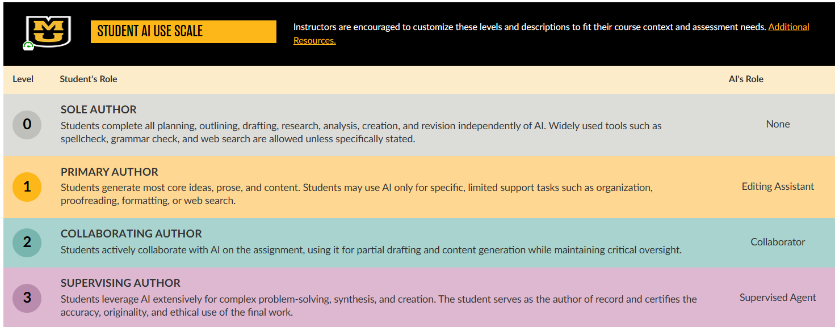
- MU Student AI Use Scale | Orientation Page: This resource is an editable template instructors can add to their Canvas site to orient their students to their AI expectations. It includes the official Mizzou AI Student Use Scale, and space to customize instructions and describe acceptable levels for different assignments. Additionally, there is an option for instructors to describe how they will use AI in their teaching, should they wish to.

(Scroll for the preview)
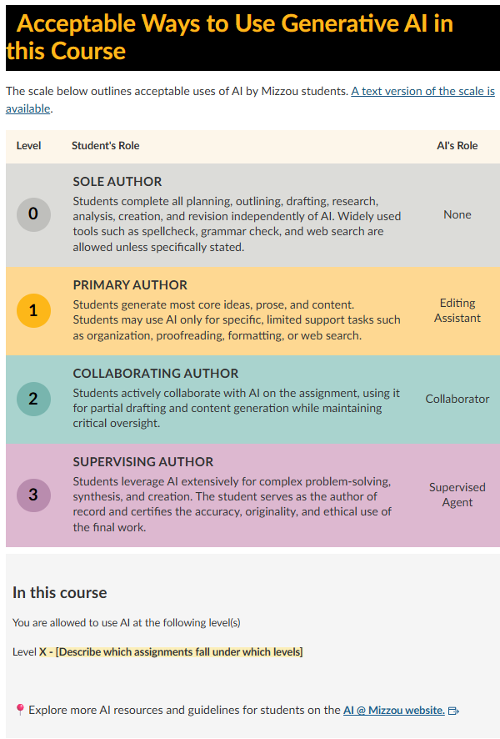

Adding the pages into your Course Site from Canvas Commons
- Log into your Canvas the way you usually do (umsystem.instructure.com
- Click on the Commons icon in Canvas' Global Navigation menu (the bar on the left-hand side of the page with your campus logo at the top). It is the second-to-last icon in the list with a right-pointing arrow in the semicircle. This is the second-to-last icon in the list.

- Click on the Filter button.
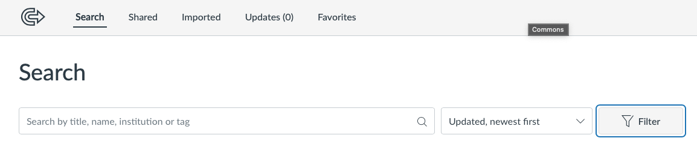
- Select the following filters: Pages, Courses, Undergraduate, Graduate.
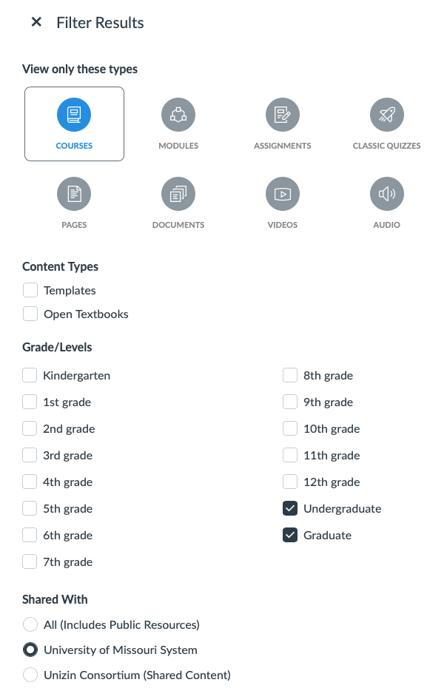
- In the search bar at the top, type in MU Students AI Use. The first two options should be the two resources mentioned above.

- Click on the Resource you want to access on the result card.
- Click on the blue Import/Download button in the right-hand side of the page.
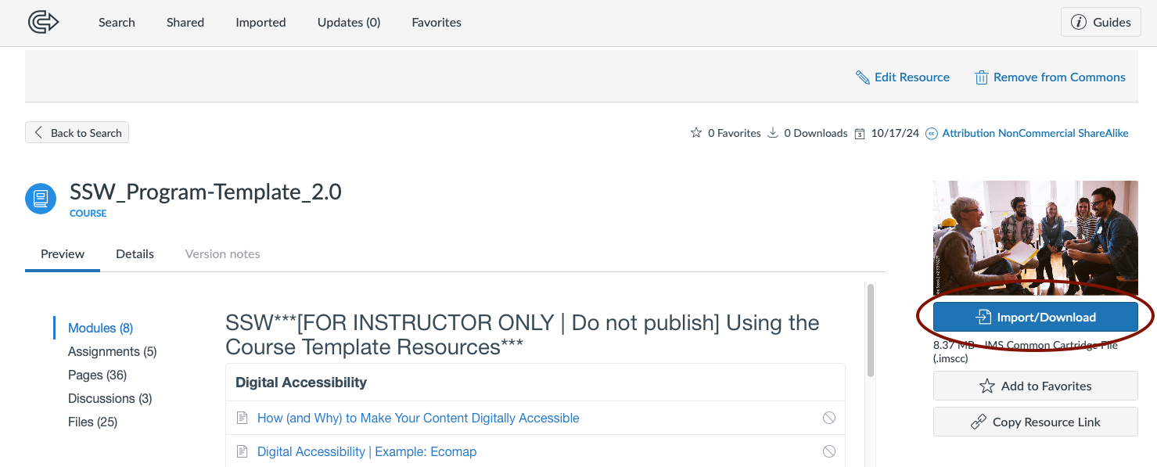
- If the course you want to import into is displayed in the list, click the box before the title.
If you do not see your course, search for it by typing in the course title as it appears in your Canvas site.
Once the desired course appears in the list, select it by clicking the box before the title.
IMPORTANT NOTE: DO NOT select “All.” This will import the template into ALL courses for which you are listed as a “Teacher.”
- Select Import into Course.
You will receive a notification when the import process starts. It may take a few minutes for the import to complete. Once the import is finished, Canvas will send you a confirmation email, and the template content will be available in your course site.

